**Lưu ý:**

* **Thay các vị trí xx bằng 2 số cuối của MSSV**
* **Thay Ho va ten SV trong Header bằng Họ tên của Sinh viên**

**Subnetting Scenario 1**

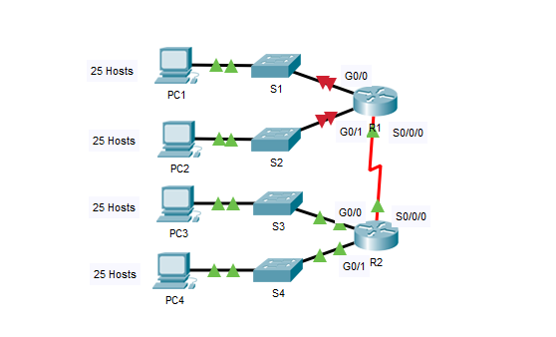

**Addressing Table**

|  |  |  |  |  |
| --- | --- | --- | --- | --- |
| **Device** | **Interface** | **IP Address** | **Subnet Mask** | **Default Gateway** |
| R1 | G0/0 |  |  |  |
| G0/1 |  |  |  |
| S0/0/0 |  |  |  |
| R2 | G0/0 |  |  |  |
| G0/1 |  |  |  |
| S0/0/0 |  |  |  |
| S1 | VLAN 1 |  |  |  |
| S2 | VLAN 1 |  |  |  |
| S3 | VLAN 1 |  |  |  |
| S4 | VLAN 1 |  |  |  |
| PC1 | NIC |  |  |  |
| PC2 | NIC |  |  |  |
| PC3 | NIC |  |  |  |
| PC4 | NIC |  |  |  |

**Objectives**

**Part 1: Design an IP Addressing Scheme**

**Part 2: Assign IP Addresses to Network Devices and Verify Connectivity**

**Scenario**

In this activity, you are given the network address of 192.168.100.0/24 to subnet and provide the IP addressing for the network shown in the topology. Each LAN in the network requires enough space for, at least, 25 addresses for end devices, the switch and the router. The connection between R1 to R2 will require an IP address for each end of the link.

**Part 1:**     **Design an IP Addressing Scheme**

**Step 1:**     **Subnet the 192.168.xx.0/24 network into the appropriate number of subnets.**

a.     Based on the topology, how many subnets are needed?

b.    How many bits must be borrowed to support the number of subnets in the topology table?

c.     How many subnets does this create?

d.    How many usable hosts does this create per subnet?

**Note:**If your answer is less than the 25 hosts required, then you borrowed too many bits.

e.     Calculate the binary value for the first five subnets. The first subnet is already shown.

Net 0: 192 . 168 . xx . 0 0 0 0 0 0 0 0

Net 1: 192 . 168 . xx . ___ ___ ___ ___ ___ ___ ___ ___

Net 2: 192 . 168 . xx . ___ ___ ___ ___ ___ ___ ___ ___

Net 3: 192 . 168 . xx . ___ ___ ___ ___ ___ ___ ___ ___

Net 4: 192 . 168 . xx . ___ ___ ___ ___ ___ ___ ___ ___

f.     Calculate the binary and decimal value of the new subnet mask.

11111111.11111111.11111111. ___ ___ ___ ___ ___ ___ ___ ___

255 . 255 . 255 . ______

 g.    Fill in the **Subnet Table**,listing the decimal value of all available subnets, the first and last usable host address, and the broadcast address. Repeat until all addresses are listed.

**Note:** You may not need to use all rows.

**Subnet Table**

|  |  |  |  |  |
| --- | --- | --- | --- | --- |
| **Subnet Number** | **Subnet Address** | **First Usable Host Address** | **Last Usable Host Address** | **Broadcast Address** |
| 0 |  |  |  |  |
| **1** |  |  |  |  |
| **2** |  |  |  |  |
| **3** |  |  |  |  |
| **4** |  |  |  |  |
| **5** |  |  |  |  |
| **6** |  |  |  |  |
| **7** |  |  |  |  |
| **8** |  |  |  |  |
| **9** |  |  |  |  |
| **10** |  |  |  |  |

**Step 2:**     **Assign the subnets to the network shown in the topology.**

a.     Assign Subnet 0 to the LAN connected to the GigabitEthernet 0/0 interface of R1:

b.    Assign Subnet 1 to the LAN connected to the GigabitEthernet 0/1 interface of R1:

c.     Assign Subnet 2 to the LAN connected to the GigabitEthernet 0/0 interface of R2:

d.    Assign Subnet 3 to the LAN connected to the GigabitEthernet 0/1 interface of R2:

e.     Assign Subnet 4 to the WAN link between R1 to R2:

**Step 3:**     **Document the addressing scheme.**

Fill in the **Subnet Table** using the following guidelines:

a.     Assign the first usable IP addresses to R1 for the two LAN links and the WAN link.

b.    Assign the first usable IP addresses to R2 for the LANs links. Assign the last usable IP address for the WAN link.

c.     Assign the second usable IP addresses to the switches.

d.    Assign the last usable IP addresses to the hosts.

**Part 2:**     **Assign IP Addresses to Network Devices and Verify Connectivity**

Most of the IP addressing is already configured on this network. Implement the following steps to complete the addressing configuration.

**Step 1:**     **Configure IP addressing on R1 LAN interfaces.**

**Step 2:**     **Configure IP addressing on S3, including the default gateway.**

**Step 3:**     **Configure IP addressing on PC4, including the default gateway.**

**Step 4:**     **Verify connectivity.**

You can only verify connectivity from R1, S3, and PC4. However, you should be able to ping every IP address listed in the **Addressing Table**.

**Designing and Implementing a VLSM Addressing Scheme**

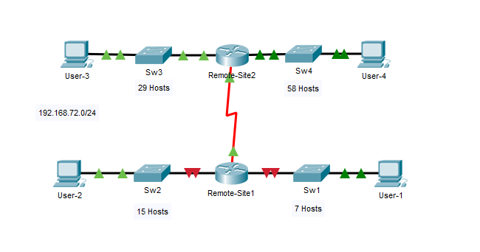

**Addressing Table**

|  |  |  |  |  |
| --- | --- | --- | --- | --- |
| **Device** | **Interface** | **IP Address** | **Subnet Mask** | **Default Gateway** |
| Remote-Site1 | G0/0 |  |  | N/A |
| G0/1 |  |  | N/A |
| S0/0/0 |  |  | N/A |
| Remote-Site2 | G0/0 |  |  | N/A |
| G0/1 |  |  | N/A |
| S0/0/0 |  |  | N/A |
| Sw1 | VLAN 1 |  |  |  |
| Sw2 | VLAN 1 |  |  |  |
| Sw3 | VLAN 1 |  |  |  |
| Sw4 | VLAN 1 |  |  |  |
| User-1 | NIC |  |  |  |
| User-2 | NIC |  |  |  |
| User-3 | NIC |  |  |  |
| User-4 | NIC |  |  |  |

**Objectives**

**Part 1: Examine the Network Requirements**

**Part 2: Design the VLSM Addressing Scheme**

**Part 3: Assign IP Addresses to Devices and Verify Connectivity**

**Background**

In this activity, you are given a /24 network address to use to design a VLSM addressing scheme. Based on a set of requirements, you will assign subnets and addressing, configure devices and verify connectivity.

**Part 1:**   **Examine the Network Requirements**

**Step 1:**     **Determine the number of subnets needed.**

You will subnet the network address 192.168.xx.0/24. The network has the following requirements:

•         **Sw1** LAN will require **7** host IP addresses

•         **Sw2** LAN will require **15** host IP addresses

•         **Sw3** LAN will require **29** host IP addresses

•         **Sw4** LAN will require **58** host IP addresses

How many subnets are needed in the network topology?

**Step 2:**     **Determine the subnet mask information for each subnet.**

a.     Which subnet mask will accommodate the number of IP addresses required for **Sw1**?

How many usable host addresses will this subnet support?

b.    Which subnet mask will accommodate the number of IP addresses required for **Sw2**?

How many usable host addresses will this subnet support?

c.     Which subnet mask will accommodate the number of IP addresses required for **Sw3**?

How many usable host addresses will this subnet support?

d.    Which subnet mask will accommodate the number of IP addresses required for **Sw4**?

How many usable host addresses will this subnet support?

e.     Which subnet mask will accommodate the number of IP addresses required for the connection between **Remote-Site1** and **Remote-Site2**?

**Part 2:**   **Design the VLSM Addressing Scheme**

**Step 1:**     **Divide the 192.168.xx.0/24 network based on the number of hosts per subnet.**

a.     Use the first subnet to accommodate the largest LAN.

b.    Use the second subnet to accommodate the second largest LAN.

c.     Use the third subnet to accommodate the third largestLAN.

d.    Use the fourth subnet to accommodate the fourth largestLAN.

e.     Use the fifth subnet to accommodate the connection between **Remote-Site1**and**Remote-Site2**.

**Step 2:**     **Document the VLSM subnets.**

Complete the **Subnet Table**,listing the subnet descriptions (e.g. Sw1 LAN), number of hosts needed, then network address for the subnet, the first usable host address, and the broadcast address. Repeat until all addresses are listed.

**Subnet Table**

|  |  |  |  |  |
| --- | --- | --- | --- | --- |
| **Subnet Description** | **Number of Hosts Needed** | **Network Address/CIDR** | **First Usable Host Address** | **Broadcast Address** |
|  |  |  |  |  |
|  |  |  |  |  |
|  |  |  |  |  |
|  |  |  |  |  |
|  |  |  |  |  |

**Step 3:**     **Document the addressing scheme.**

a.     Assign the first usable IP addresses to **Remote-Site1** for the two LAN links and the WAN link.

b.    Assign the first usable IP addresses to **Remote-Site2** for the two LANs links. Assign the last usable IP address for the WAN link.

c.     Assign the second usable IP addresses to the switches.

d.    Assign the last usable IP addresses to the hosts.

**Part 3:**   **Assign IP Addresses to Devices and Verify Connectivity**

Most of the IP addressing is already configured on this network. Implement the following steps to complete the addressing configuration.

**Step 1:**     **Configure IP addressing on Remote-Site1 LAN interfaces.**

**Step 2:**     **Configure IP addressing on Sw3, including the default gateway.**

**Step 3:**     **Configure IP addressing on User-4, including the default gateway.**

**Step 4:**     **Verify connectivity.**

You can only verify connectivity from Remote-Site1, Sw3, and User-4. However, you should be able to ping every IP address listed in the **Addressing Table**.

**Implementing a Subnetted IPv6 Addressing Scheme**

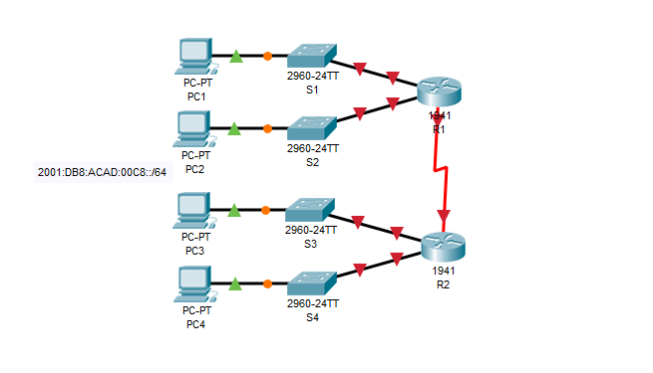

**Addressing Table**

|  |  |  |  |
| --- | --- | --- | --- |
| **Device** | **Interface** | **IPv6 Address** | **Link-Local** |
| R1 | G0/0 |  | FE80::1 |
| G0/1 |  | FE80::1 |
| S0/0/0 |  | FE80::1 |
| R2 | G0/0 |  | FE80::2 |
| G0/1 |  | FE80::2 |
| S0/0/0 |  | FE80::2 |
| PC1 | NIC | Auto Config | |
| PC2 | NIC | Auto Config | |
| PC3 | NIC | Auto Config | |
| PC4 | NIC | Auto Config | |

**Objectives**

**Part 1: Determine the IPv6 Subnets and Addressing Scheme**

**Part 2: Configure the IPv6 Addressing on Routers and PCs and Verify Connectivity**

**Scenario**

Your network administrator wants you to assign five /64 IPv6 subnets to the network shown in the topology. Your job is to determine the IPv6 subnets, assign IPv6 addresses to the routers, and set the PCs to automatically receive IPv6 addressing. Your final step is to verify connectivity between IPv6 hosts.

**Part 1:**     **Determine the IPv6 Subnets and Addressing Scheme**

**Step 1:**     **Determine the number of subnets needed.**

Start with the IPv6 subnet 2001:DB8:ACAD:00XX::/64 and assign it to the R1 LAN attached to GigabitEthernet 0/0, as shown in the **Subnet Table**. For the rest of the IPv6 subnets, increment the 2001:DB8:ACAD:00XX::/64 subnet address by 1 and complete the **Subnet Table** with the IPv6 subnet addresses.

**Subnet Table**

|  |  |
| --- | --- |
| **Subnet Description** | **Subnet Address** |
| R1 G0/0 LAN | 2001:DB8:ACAD:00XX::0/64 |
| R1 G0/1 LAN |  |
| R2 G0/0 LAN |  |
| R2 G0/1 LAN |  |
| WAN Link |  |

**Step 2:**     **Assign IPv6 addressing to the routers.**

a.     Assign the first IPv6 addresses to R1 for the two LAN links and the WAN link.

b.    Assign the first IPv6 addresses to R2 for the two LANs. Assign the second IPv6 address for the WAN link.

c.     Document the IPv6 addressing scheme in the **Addressing Table**.

**Part 2:**     **Configure the IPv6 Addressing on Routers and PCs and Verify Connectivity**

**Step 1:**     **Configure the routers with IPv6 addressing.**

**Note:**This network is already configured with some IPv6 commands that are covered in a later course. At this point in your studies, you only need to know how to configure IPv6 address on an interface.

Configure R1 and R2 with the IPv6 addresses you specified in the **Addressing Table**and activate the interfaces.

Router(config-if)# **ipv6 address***ipv6-address/prefix*

Router(config-if)# **ipv6 address***ipv6-link-local***link-local**

**Step 2:**     **Configure the PCs to automatically receive IPv6 addressing.**

Configure the four PCs for autoconfiguration. Each should then automatically receive full IPv6 addresses from the routers.

**Step 3:**     **Verify connectivity between the PCs.**

Each PC should be able to ping the other PCs and the routers.